**Code Guide**

This code is based on the paper : M. Pourfard, K. Faez, S. Tabaian, "[Autocorrelation-based Method for Characterization of the Self-hexagonal Lattice](https://pubs.acs.org/doi/abs/10.1021/jp401504q)", The Journal of Physical Chemistry C, 2013 [[**IF=4.189**](https://pubs.acs.org/page/jpccck/about.html)**]** [**[Q1]**](https://www.scimagojr.com/journalsearch.php?q=5200153123&tip=sid&clean=0)[**[PDF]**.](https://www.researchgate.net/publication/261712062_Autocorrelation-Based_Method_for_Characterization_of_the_Self-_Hexagonal_Lattice?_sg%5B0%5D=qBhIGb8uzW3v-7l_VLPS5uJOxy5AJStk4vDgSBOgxLmidPjNLpZNsfAPCi3CXZlwUpiV1s9p-uNx9o6TIuHOUMi71tvbqIKv85t_CIwR.vg4gVMF4RZjSq0AdEyPvoT5cD0YaWgBUJHxb1N1tP-FnEyWiN40fw8-s37QpfMyT2iV3YGufQjVjbvrF3bGQ8g)

If you have used the code you must cite the above paper.

Code Language: MATLAB

Date of code: 2013

Producer: Mohammadreza Pourfard

Email: [pourfardm@gmail.com](mailto:pourfardm@gmail.com)

**How to run the code?**

1. Run the guide command in matlab
2. select browse button to choose the image (e.g. 1-1-2-.tif)
3. Press run autocorrelation

The code is embedded in guide version but if you want to run the non-guided version please run the **nano_autocorrelation.m** code.

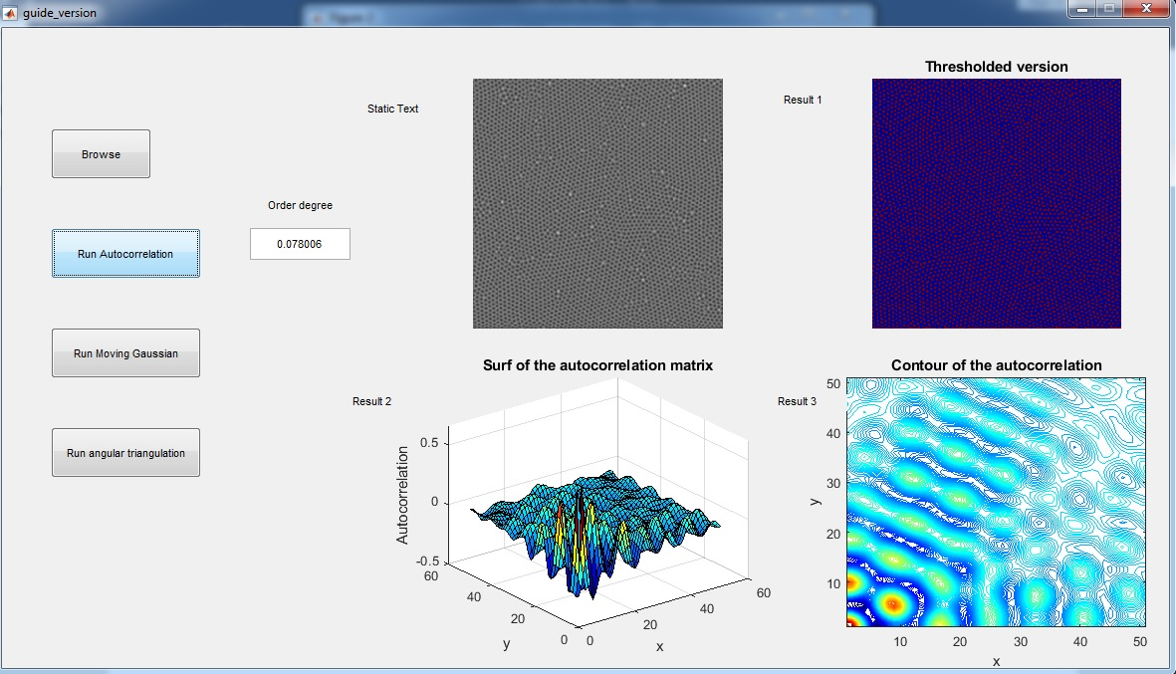

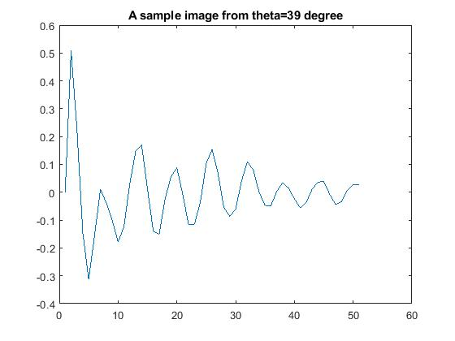

Figure 1 is the peaks and valleys of a predefined orientation

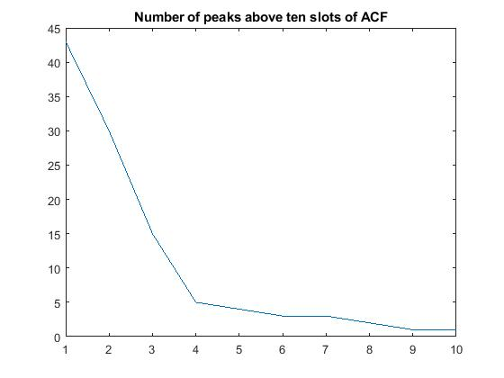

Figure 2 is the peaks above each slot